COMPARIONS BETWEEN CSHARP AND PYTHON
Let us look at the codes we provided
C#
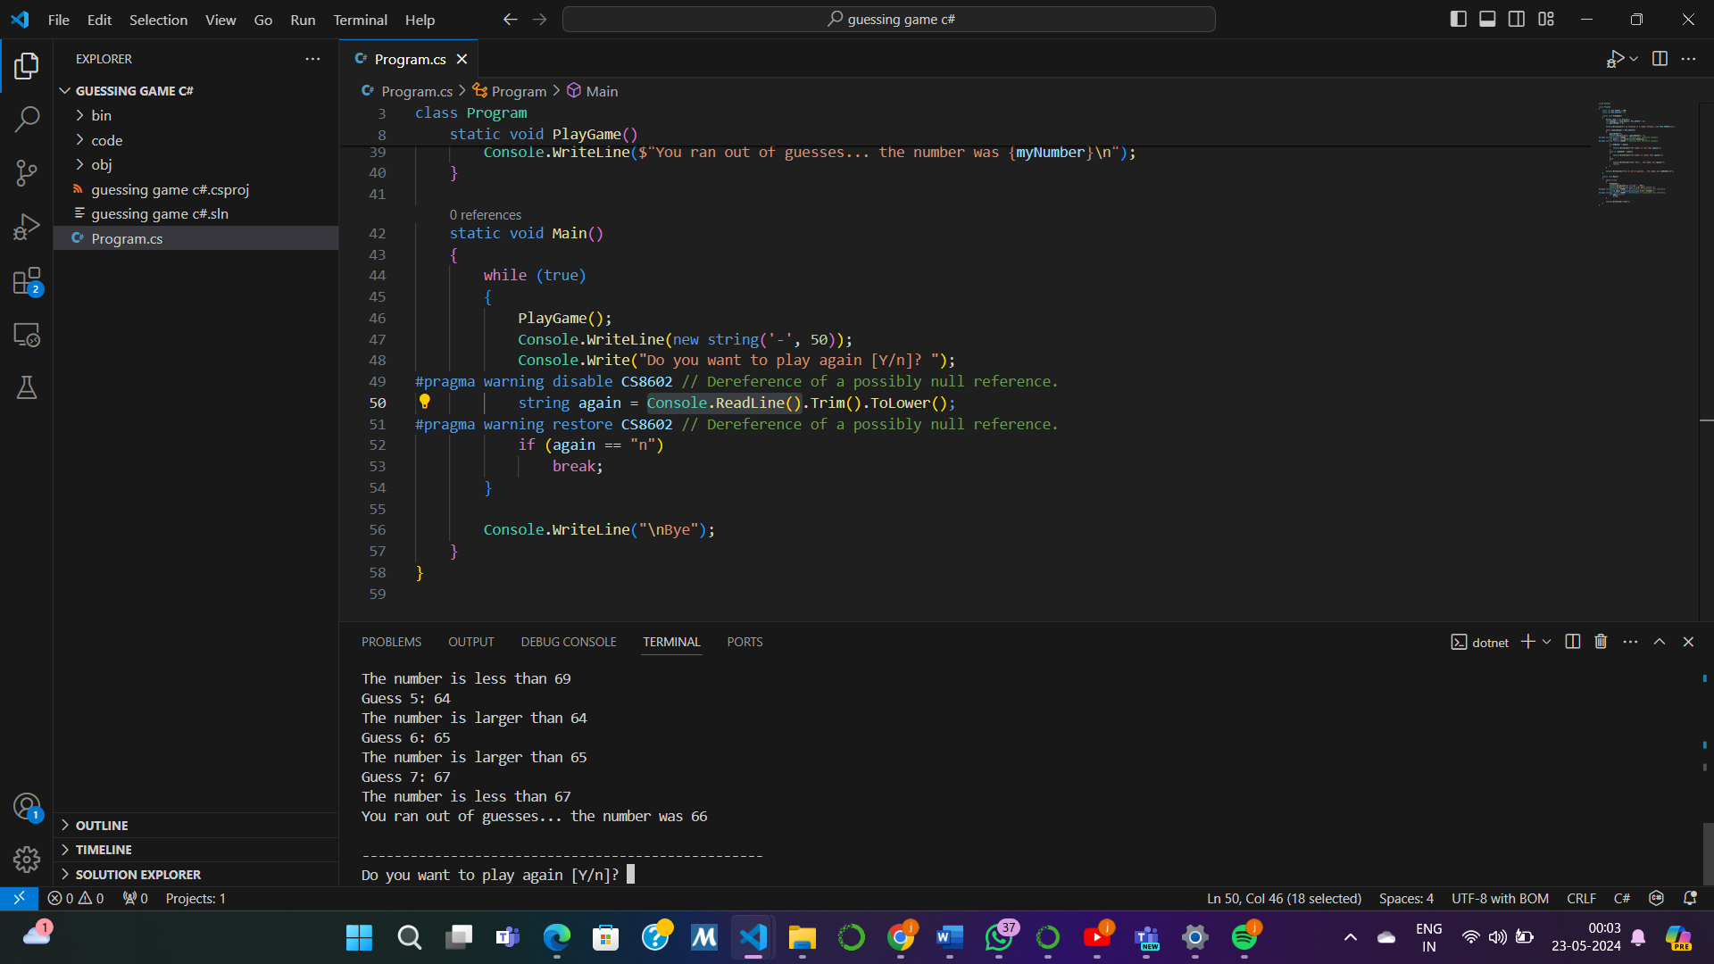

Python
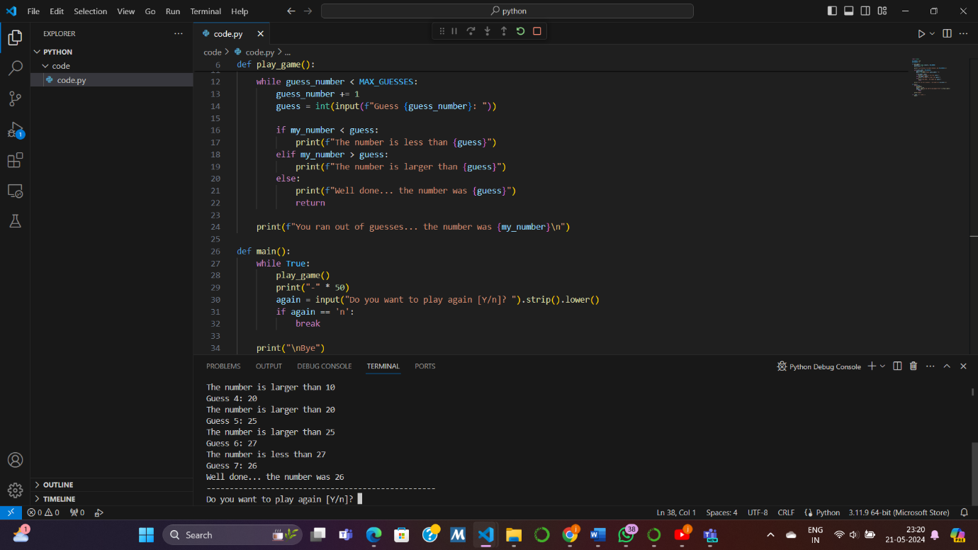
WE CAN COMPARE THESE CODES ON THE BASIS OF A FEW PARAMETERS :
Imports and Constants
Python: Uses import random for random number generation.
C#: Uses using System; for basic functionality and Random class for random number generation.
Function Definitions
Python: Functions are defined using def keyword. Example: def play_game():.
C#: Methods are defined using static void. Example: static void PlayGame().
Random Number Generation
Python: random.randint(1, MAX_NUMBER).
C#: rand.Next(1, MAX_NUMBER + 1).
Input and Output
Python: Uses input() for reading user input and print() for output.
C#: Uses Console.ReadLine() for input and Console.WriteLine() for output.
String Formatting
Python: Uses f-strings for formatting. Example: print(f"I am thinking of a number between 1 and {MAX_NUMBER}\n").
C#: Uses $ before the string for interpolation. Example: Console.WriteLine($"I am thinking of a number between 1 and {MAX_NUMBER}\n");.
Conditional Statements
Python: Uses if, elif, and else for conditionals.
C#: Uses if, else if, and else.
Looping
Python: Uses while loop. Example: while guess_number < MAX_GUESSES:.
C#: Uses while loop in the same way. Example: while (guessNumber < MAX_GUESSES).
Main Function
Python: Checks if __name__ == "__main__": to run the main function.
C#: Uses static void Main() as the entry point.
Running the application
We generally use ‘dotnet run’ to execute the csharp code. While we can use f5 shortcut to run the python code.
Summary
Both the Python and C# versions of the game are structurally similar but differ in syntax and some built-in functions. Python's code is generally more concise and easier to read due to its high-level nature, while C# is more verbose and requires explicit type declarations and method structures.

